Extent of Play Agreement
  - For Shared Response 2019
  - March 5-7, 2019

Purpose
This Extent of Play Agreement (XPA) identifies the conditions that will be used to develop, conduct, control, and evaluate the Shared Response Functional Exercise in March 2019. The Idaho Office of Emergency Management would like to know the level of participation your organization intends to have in the exercise.

Executive Summary
The Idaho Office of Emergency Management is planning a 3 day functional exercise that will provide an opportunity for ESF partners to validate plans, policies, procedures, and capabilities in response to an earthquake that significantly impacts Southeast Idaho.

Identified Exercise Objectives and Core Capabilities
Exercise Objective | Aligned Core Capability
- Implement risk-informed guidelines, regulations, and standards to ensure the security, reliability, integrity, and availability of critical information, records, and communications systems and services through collaborative cybersecurity initiatives and efforts.  - Implement and maintain procedures to detect malicious activity and to conduct technical and investigative-based countermeasures, mitigations, and operations against malicious actors to counter existing and emerging cyber-based threats, consistent with established protocols. | Cyber Security
- Ensure the capacity to communicate with both the emergency response community and the affected populations and establish interoperable voice and data communications between Federal, tribal, state and local first responders.  - Re-establish sufficient communications infrastructure within the affected areas to support ongoing life-sustaining activities, provide basic human needs, and transition to recovery.  - Re-establish critical information networks, including cybersecurity information sharing networks, in order to inform situational awareness, enable incident response, and support the resiliency of key systems. | Operational Communication
- Mobilize all critical resources and establish command, control and coordination structures within the affected community and other coordinating bodies in surrounding communit8ies and across the Nation and maintain as needed throughout the duration of an incident.  - Enhance and maintain command, control, and coordination structures, consistent with the National Incident Management System (NIMS), to meet basic human needs, stabilize the incident, and transition to recovery. | Operational Coordination

Standards & References
The Idaho Office of Emergency Management will use the following references, plans, and procedures during exercise play:
- State of Idaho EOP

Exercise Parameters
The exercise will be a 3 day functional exercise at Gowen Field in the State EOC with a separate SimCell for MSEL execution.
Scenario:
M7.5 Earthquake in Bannock County, along the Wasatch Fault 20 miles south of Lava Hot Springs. A major landslide has been reported along US 30 in Lava Hot Springs with derailment of a train just above the highway. Train was carrying sulfuric acid, which is threatening to enter the Portneuf River below.
 | Possible incidents | Desc | Location
1 | Overpass Failure | Petroleum rupture | Inkom – I15
2 | Overpass Failure | I 86 railway underpass collapse | Pocatello – I86
3 | Runway | Compromised | Pocatello Regional Airport
4 | Railway | Derailment HAZMAT | Lava Hot Springs
5 | Tank Farm | Rupture? Leak? | Pocatello
6 | Communication Loss |  | Chinese and/or Sedgwick Peak
7 | Simplot Don Plant Exposure | Anhydrous Ammonia | Pocatello
8 | Simplot Smoky Canyon Exposure |  | Soda Springs

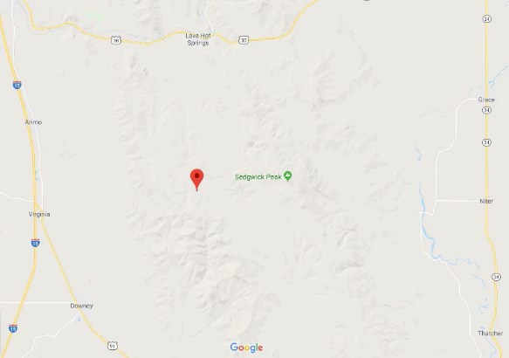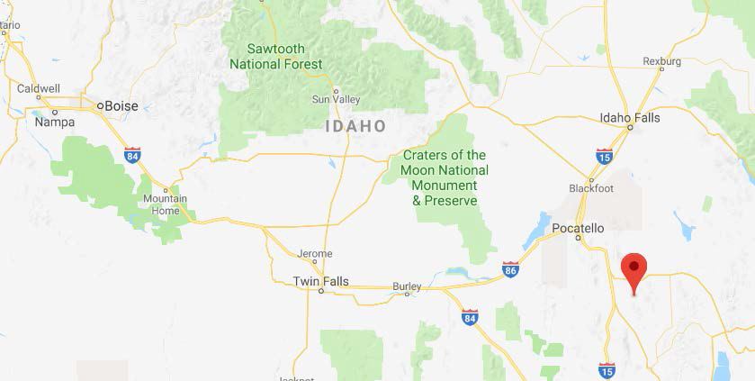

Exercise Participants

SUBMITTING ORGANIZATION: ___________________________
Roles:
- Players – respond realistically to the exercise (EOC Staff/ESF Partners)
- SimCell Staff - A SimCell is a location from which controllers deliver telephone calls, radio messages, facsimiles, and other types of messages—these messages represent actions, activities, and conversations of an individual, agency, or organization that is not participating in the exercise but would likely be actively involved during a real incident.
- Evaluators – collect information for evaluation
- Observers – watch exercise play, but do not participate
- Planning Team – trusted agent that participates in planning the exercise, cannot be a player.
Extent of Play: The level of participation your organization intends to have in the exercise. Describe, as closely as possible, what play in the exercise will look like from your organization’s point-of-view.

Participant | Exercise Role
(Name, Position, & Organization Name) | (Planning, Player, SimCell, Evaluator, Observer)
Extent of Play:

