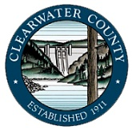
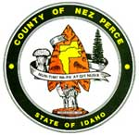
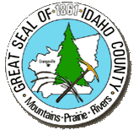
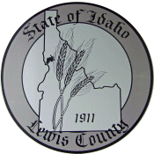
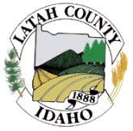

Thursday, Jan. 12th, 2023 (9:00 a.m. Pacific)
Brammer Building (1225 Idaho St.); Lewiston, Idaho
(*Possible Action Items*)

9:00 a.m. Introductions, prior meeting minutes; quorum and proxies; agenda changes, virtual connection information/assistance

Open session

9:10 a.m. *IPSCC and Committee Updates*: Dave Taylor: DaveTaylor@co.nezperce.id.us;
- Initiative to Merge IPSCC Tech Committees- Status & Rationale
- Funding Support for Idaho NG-911
- State Funding for Broadband Fiber
- DIGB2 Projects and Grant / Funding efforts

9:35 a.m. SWIC Information: Brian Shields: bshields@imd.idaho.gov (208-258-6566)
- Idaho TICP & FOG
- IPSCC Initiatives and Other State & Idaho DIGB Projects

9:50 a.m. *DIGB2 & Regional Fiber Task Force Project Reports*:
- Grangeville – New Meadows Fiber Feasibility Final Report
- Other Sharable Project Information

10:15 a.m. Break

10:30 a.m. *DIGB2, Regional & State GIS/NG911 Update*: Bill Reynolds; BillReynolds@co.nezperce.id.us

10:45 a.m. *Win Link Exercise, AAR & Improvement Plan*: Don Gardner: dgardner@clearwatercounty.org (208-476-4064)

11:00 a.m. *Inland Northwest LECC Em. Alert Syst. Plan*: J. Zumalt jzumalt@idahocounty.org (208-983-3074)

11:15 a.m. *DIGB2 Member Business & Information (considerations and decisions*):
- D2 PSAP and LMR Updates & Initiatives- all
- D2 Public / Private Sector Information-
- Other DIGB & Region 2 Participant New Business / Information-

11:15 a.m. Adjourn-Next Meeting: Location/Date: Lewiston- Thursday 9 March 2023

Voting members: Clearwater County: Don Gardner; Mitch Jared. Idaho County: Jerry Zumalt; Terry Cochran. Latah County: Tim Besst; Roger Lanier; Mike Neelon. Lewis County: Jason Davis; Bob West. Nez Perce County: Bill Reynolds; Brian Birdsell and Dave Taylor. Nez Perce Tribe: Leotis McCormack; John Wheaton.
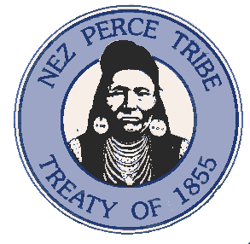
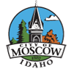

The GoToMeeting link for the DIGB2 meeting on Thursday, January 12th is:
Please join my meeting from your computer, tablet or smartphone:
DIGB2 - Thursday, Jan 12, 2023, 9:00 AM - 4:00 PM (PST)
Please join my meeting from your computer, tablet or smartphone.
https://meet.goto.com/604166461
You can also dial in using your phone.
United States: +1 (408) 650-3123
Access Code: 604-166-461
Get the app now and be ready when your first meeting starts: https://meet.goto.com/install

