[County] Evacuation Plan
[Month Year]
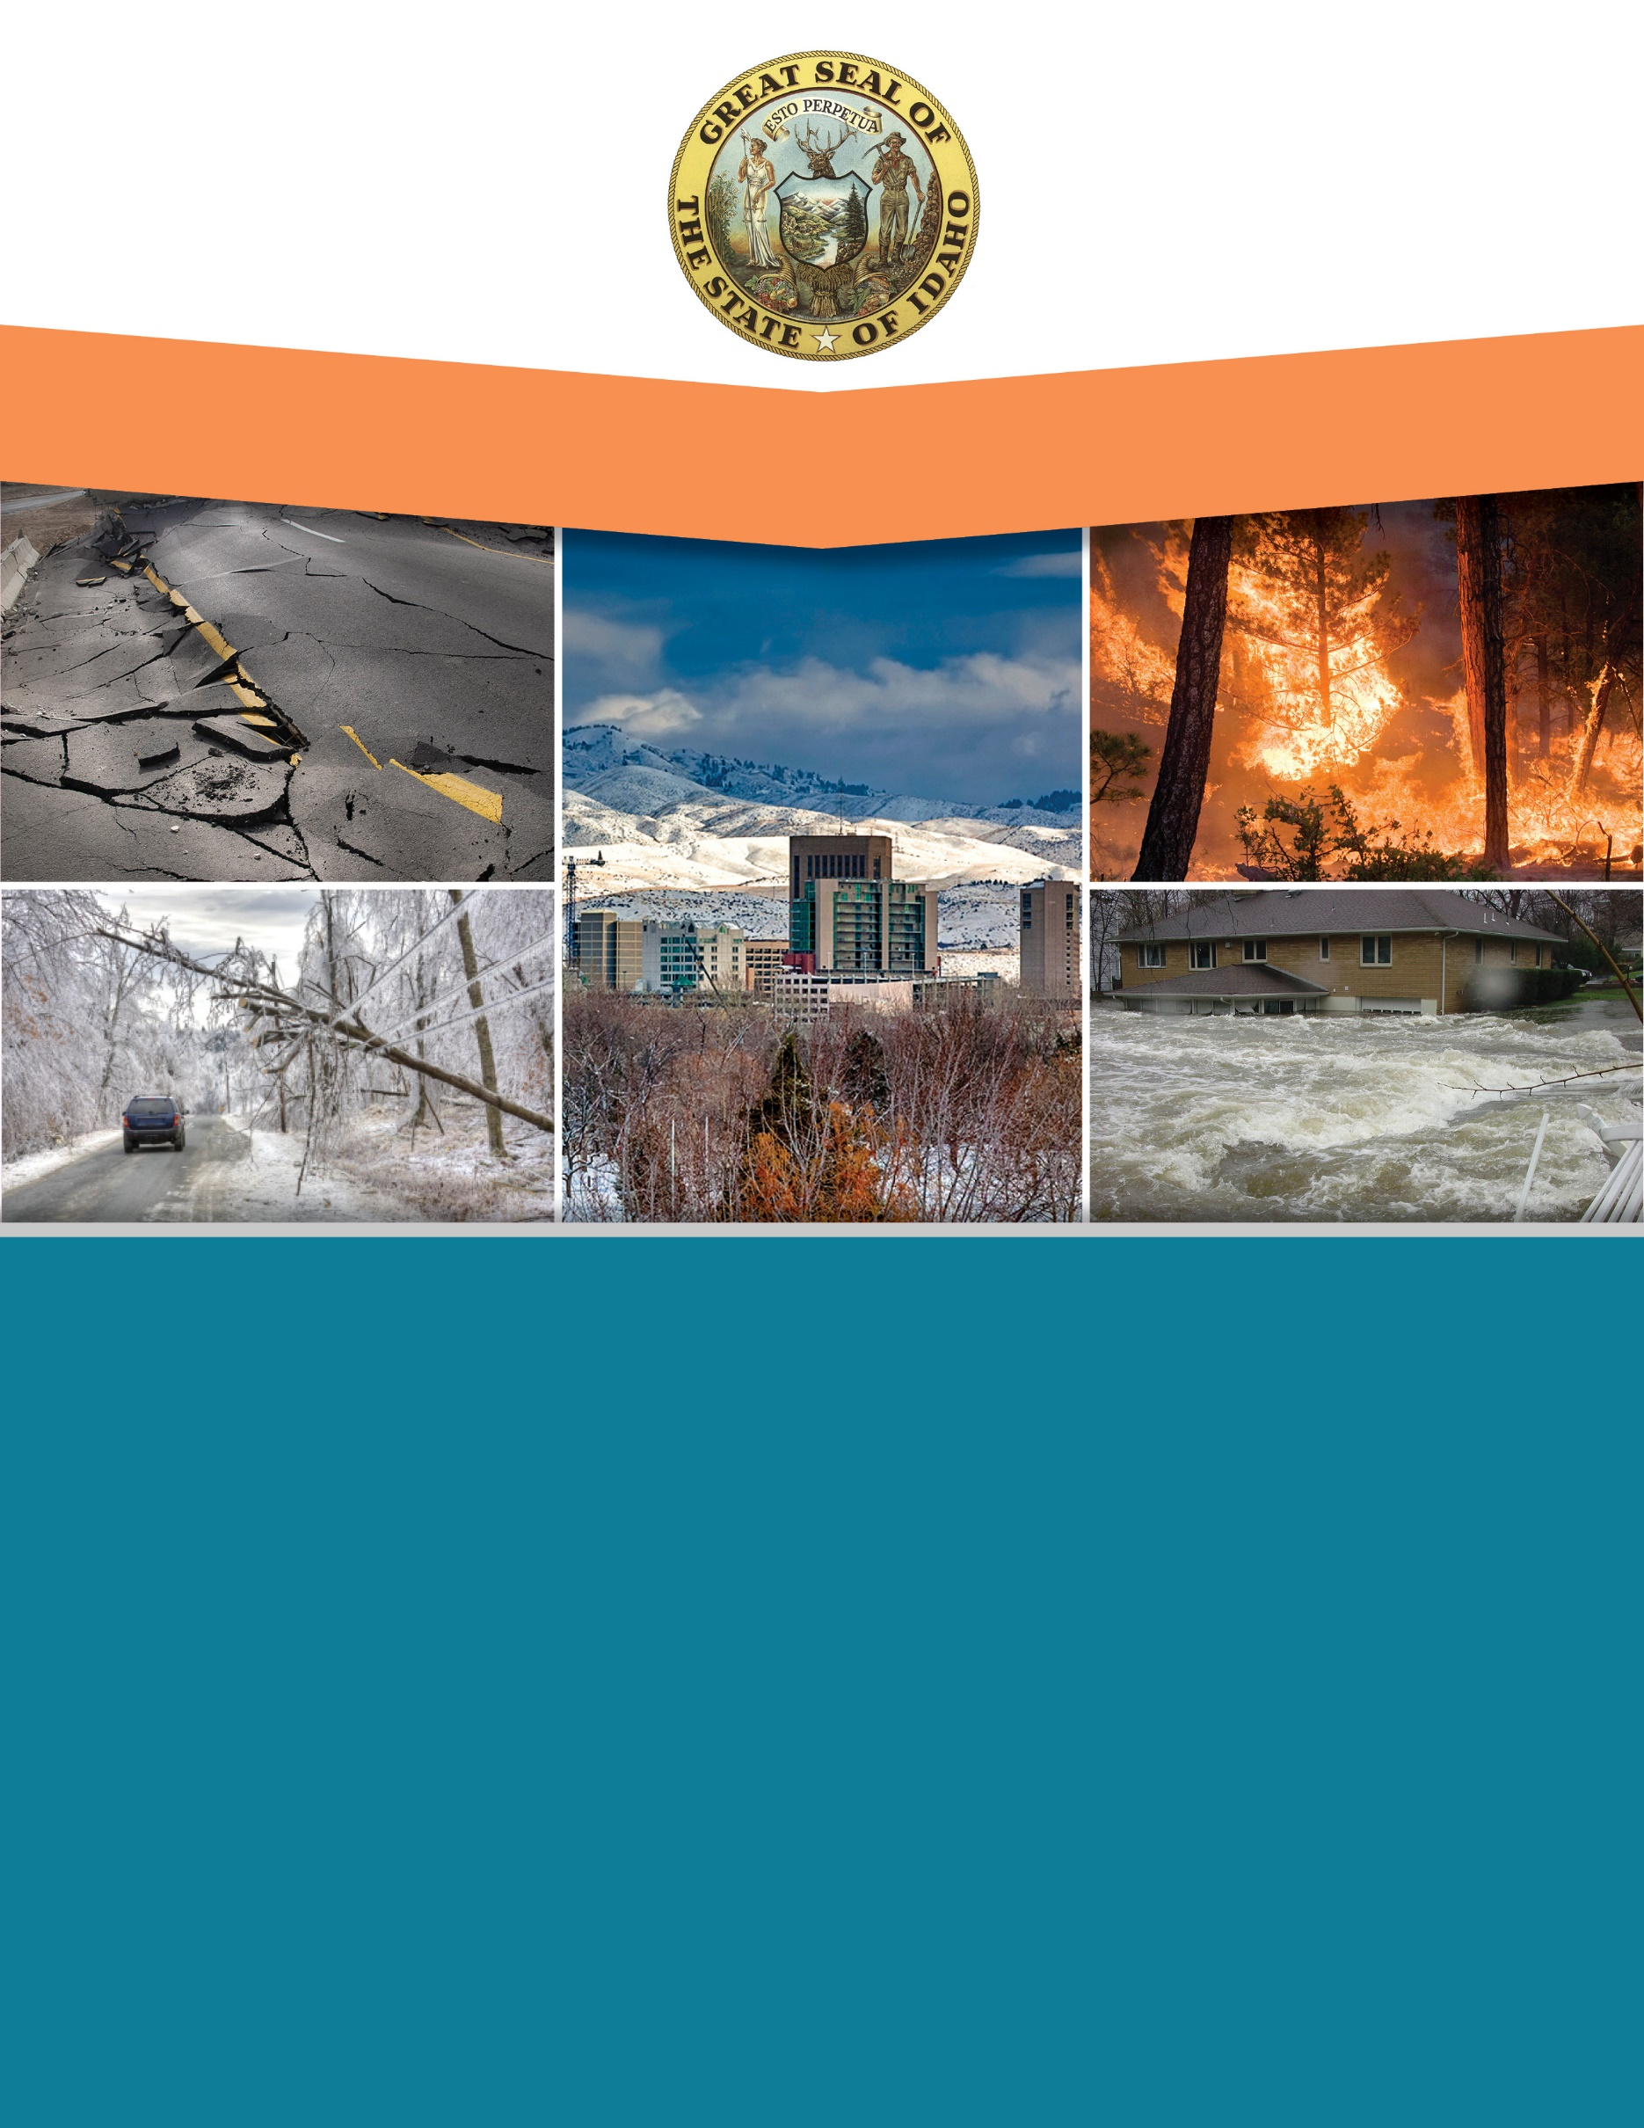

Signature Page

(Name), (Title) (Name), (Title)
(Name of Organization) (Name of Organization)

(Name), (Title) (Name), (Title)
(Name of Organization) (Name of Organization)

(Name), (Title) (Name), (Title)
(Name of Organization) (Name of Organization)

(Name), (Title) (Name), (Title)
(Name of Organization) (Name of Organization)

Record of Changes
Date | Plan Section | Change | Who Posted

Plan Maintenance: The [County] Emergency Management Office will review and update this plan [annually]. Exercises, AAR’s, and real-world events will inform revisions as needed.

To update the table of contents, right click in the TOC and select Update Field and then Update Entire Table. The TOC is set up for 2 heading levels.

Table of Contents
Introduction (Sample Heading 1) 1
Heading 2 1
Heading 3 1
Bullets 1
Numbers 1
Table Formatting 2
Figures 2
Appendix A: Title A-1

Evacuation Quick Guide
Evacuation zones and guidelines are found in this document in [Section Name].
First Responders may take immediate action in removing individuals from harm’s way.

Authority:

In [County Name], the authority to order an evacuation lies with the [County Sheriff] or [Incident Commander] operating under a declared emergency, per Idaho Code Title 46, Chapter 10. This authority may be delegated in writing to another official if the [Sheriff or IC] is unavailable.
Notification Methods and Alerting Residents:
- IPAWS and CodeRED alerts (English and Spanish)
- Local radio/TV broadcast messages
- County social media updates
- Door-to-door notification by law enforcement and fire with hi-lo sirens and PA systems
- Amateur radio backup if cell/data fail

Evacuation Levels and Definitions:
Evacuation Order: Immediate threat to life. Leave now — the area is closed to public access.
Evacuation Warning: Potential threat to life or property. Leave as soon as practical.
Shelter-in-Place: Stay indoors, close and lock windows/doors, and await further instructions.
Repopulation: Formal lifting of evacuation orders after hazard removal and safety checks.
Refusal Protocol:
- Advise adult residents of Evacuation Order and risks
  - Document name, contact info, and any dependents
  - Notify Incident Command and note refusal for follow-up
- Children and Dependents:
  - [Parents/Caregivers/Conservators/Legal Guardians of children and mentally impaired dependents have no legal right to put the person they are responsible for in harm’s way. Law enforcement has the authority to remove children and the mentally impaired.]

Plan Overview

Purpose
This plan provides a structured approach to coordinate the safe and timely evacuation of people and animals from threatened areas, maintain public order, and ensure consistent communication across responding agencies. This plan’s aim is to also facilitate the multi-agency and multi-jurisdictional coordination during evacuations particularly between [County Name] and the adjoining counties/tribes/districts and public utilities as well as state and federal agencies. It addresses evacuations that exceed the day-to-day capabilities of public safety agencies and is designed using an all-hazards approach to ensure applicability across a broad range of potential threats and hazards. Life safety is the highest priority in the management and execution of this plan.

Scope
Applies to all jurisdictions within [County Name] and is integrated into the County Emergency Operations Plan (EOP), Idaho Emergency Operations Plan (IDEOP), and National Incident Management System (NIMS). In disaster situations, emergency management starts at the local level and expands to include regional, state, federal and private/non-profit sector assets as the impacted jurisdictions require additional resources and capabilities.

Plan Limitations
[Insert/add/takeaway your Jurisdictions specific plan limitations]
- Does not cover small-scale relocations handled at the department level. Focuses on evacuations requiring multi-agency coordination and/or exceeding local resources
- This plan does not replace individual agency standard operating procedures (SOPs) or tactical guidelines. Agencies are expected to integrate this plan with their own operational protocols
- Successful implementation relies on available personnel, equipment, and transportation assets at the time of the incident. During widespread disasters or concurrent incidents, mutual aid resources may be limited or delayed
- While this plan is all-hazards in nature, certain hazards (e.g., dam failure, hazardous materials releases) may require additional hazard-specific annexes for technical guidance and modeling data
- In rural and mountainous areas, single-access roads, seasonal closures, and weather conditions may severely limit evacuation options. These constraints may require shelter-in-place strategies when evacuation is not feasible
- Evacuation success is contingent on timely public warning. Communication system failures (cell, internet, power) may reduce the reach of official evacuation messages, requiring alternative or in-person notification methods
- While every effort will be made to ensure the safety of evacuees and responders, hazard unpredictability (e.g., sudden wildfire wind shifts, dam break surges) may pose residual risks even during evacuation operations.

Planning Areas
Evacuation, Areas, Zones & Routes
The county is divided into [X] Planning Areas based on hazard exposure, population centers, and transportation corridors. Each planning area is further subdivided into Evacuation Zones for targeted evacuation orders.
Evacuation Planning Areas
Planning Area | Area of County | Major Population Areas | Major Routes
[Area 1] | North | [Town names]
[Area 2] | South / Southcentral | [City names]
[Area 3] | East | [Neighborhood names]

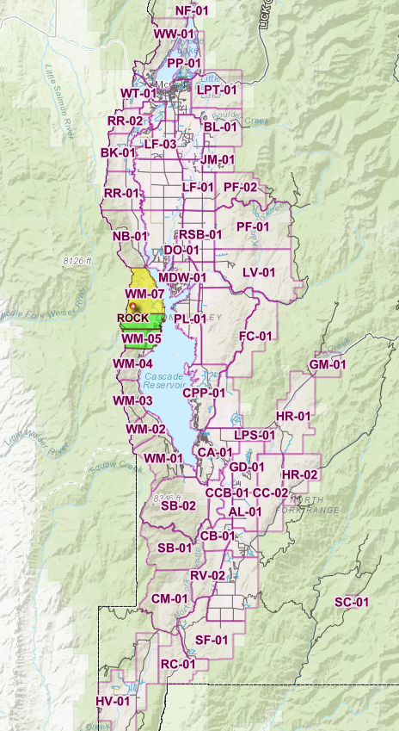
[Attach County Map with labeled Planning Areas, Zones, and Routes]
Hazards That Could Require Evacuation
Community/Area | Wildfire | Flood | Dam Failure | HAZMAT | Earthquake
[Community Name] | X |  | X | X | X
[Community Name] |  | X | X |  | X
[Community Name] | X | X |  |  | X
Note: Earthquakes do not engender evacuations, however, the cascading effects of fire and hazardous materials spills associated with earthquakes may.

Evacuation Management
Decision Points
[Insert/add/takeaway your Jurisdictions specific decision points]
The decision to evacuate will be based on maximizing the preservation of life first, then protecting the environment, property and the economy. Several factors will need to be considered including:
- Is there an immediate threat to life?
- Can critical population be moved in time?
- Is there a capacity to safely move or shelter all population groups?
- Are safe evacuation routes open and viable? Are Transportation systems and roadway conditions viable?
- What is the predicted weather forecast?
- What is the rate of spread (wildfire), level of fooding, and plume size (HAZMAT)?
- What is the projected hazard growth in the next [1-6] hours?
- What is the expected event duration? This will influence the decision to evacuate or shelter in place.

Authorities
In [County Name], only the [Sheriff (or his/her designee)] has the authority to authorize the issuance of evacuation orders. Once an event exceeds the capability of local first responders, the [Sheriff], normally working in Unified Command, has the authority and responsibility to issue and carry out necessary evacuation orders in coordination with the Incident Commander and County Emergency Manager. [Include a delegation of authority statement if appropriate, for when the primary sheriff or IC is unavailable]

Incident Command Posts/Emergency Operations Center
In cases where the event involves a countywide or large-scale emergency, the County Emergency Operations Center (EOC) will be activated. The EOC provides countywide executive-level policy, emergency public information, and coordination. The EOC may provide this in support of one or more Incident Command Posts (ICP) established by response agencies or in support of Operational Area cities or special districts’ EOCs. ICPs and their Incident Commanders are delegated legal authority to command-and-control responses in the field. The EOC does not direct response but rather coordinates and ensures that all ICPs are supported well and operate in compliance with County policies. Mutual aid is activated through Idaho’s mutual aid compact or EMAC if needed. [Detail the ICP/EOC primary and alternate locations, activation triggers, communication pathways and the specific evacuation roles they will play].

Alerting
Alerting: Insert your jurisdictions specific alerts and warnings procedures here
- IPAWS/CodeRED/Wireless Emergency Alerts (WEA) for immediate push alerts.
- Social media, traditional media (Radio, Print, and TV) & local broadcasters for situational updates. [Describe how a joint information center (JIC) works in your jurisdiction.]
- Door-to-door notification for rural/AFN residents. LE and Fire, use their HI – LO siren function and PA systems to alert residents of evacuation orders.
- Amateur radio as backup. [Describe how your jurisdictions amateur radio operations are conducted.]
Alerts and Warnings should reflect the diversity and needs of the population. Multilingual, auditory and visual notifications should be considered whenever possible.

Public Information and Joint Information System (JIS)
Effective public communication is essential for successful evacuation operations. Public information activities will be coordinated through the Joint Information System (JIS) to ensure accurate, timely, and consistent messaging across all responding agencies and jurisdictions. A Joint Information Center (JIC) may be activated to manage media relations, social media updates, rumor control, and public inquiries, as well as to monitor media and online platforms for misinformation or emerging concerns. The JIS will utilize multiple communication platforms, including IPAWS, CodeRED, local radio and television, social media, and county websites, with specific consideration for rural communities and individuals with access and functional needs (AFN). All public messaging will be coordinated with the Incident Command/Unified Command and the County Emergency Manager to provide clear instructions for evacuation levels, routes, shelter locations, and re-entry information.

Situations & Assumptions:

[Insert/add/takeaway your jurisdictions situations and assumptions]
- Evacuation compliance is far from universal. Only about half of citizens comply in mandatory zones.
- Rural populations are less likely to evacuate, due to perceived lower risk.
- Some residents will not comply; law enforcement presence may be required with follow-up door to door alerts and coordination with AFN populations.
- In some situations and areas, there are a very limited number of public safety resources available to facilitate an evacuation order.
- In some situations and areas, mutual aid resources from neighboring jurisdictions coming to assist with evacuations are not readily available and will take time to deploy.
- Self-evacuators may cause unexpected traffic congestion.
- Evacuees leaving voluntarily are more likely to seek shelter with friends or relatives or use hotels rather than public shelter.
- The proportion of the population that will evacuate typically increases as a threat becomes more obvious and serious to the public.
- During a large evacuation, there may not be enough transport capacity available to safely move the people and pets needing to evacuate.
- Evacuations will require strategies that specifically address the challenges associated with moving vulnerable or high-risk populations.
- Livestock and pet evacuation are major delay factors.
- Seasonal tourism can double local population.

Considerations and Guidance
[Insert/add/takeaway your jurisdictions specific considerations and guidance]
Transportation:
- Every effort should be made to encourage evacuees, to utilize their own vehicles. Residents without a vehicle should be encouraged to carpool or seek a Temporary Refuge Area
- Resources include [County School District buses], [Regional Transit Authority vehicles], and [ADA-compliant vans]
- MOUs in place with private bus companies for surge capacity
- Staging areas pre-identified at fairgrounds, high schools, and large parking lots.
- [Consult the hub and spoke or point to point evacuation transportation models, from the “FEMA Planning Considerations: Evacuation and Shelter in Place 2019 document
  - Planning Considerations: Evacuation and Shelter-in-Place - Guidance for State, Local, Tribal and Territorial Partners]

Evacuation Route Selection:
- Shortest safe path to designated shelters/refuge areas
- The maximum number of lanes that provide continuous flow through the evacuation area, avoiding known hazard choke points (low bridges, landslide zones) and minimizing traffic crossing conflicts at intersections
- Availability of infrastructure to disseminate real-time conditions and messages to the traveling public (e.g., media and variable message traffic boards/signs)
- Availability of real-time traffic flow and route condition information to decision makers and the public (e.g., from closed-circuit television cameras, traffic detectors, or spotters)
- Identify backup routes in case of blockage

Traffic Control Plans:
- TCPs staffed by Sheriff’s Office, Idaho State Police, or volunteer CERT teams.
- Barricades stored at [Public Works Yard location]
- Pre-scripted lane reversal plans for [Highway X] if needed

Perimeter Security:
- Law enforcement maintains access control at evacuated zones.
- Resident re-entry passes issued post-event

Access & Functional Needs (AFN) Populations:
- Registry maintained by [County Health & Welfare.]
- Transport arranged via ADA-compliant buses or EMS units
- AFN notification messages tailored for sensory, mobility, and cognitive impairments

School Evacuations:
- Utilize pre-arranged relocation sites and transportation contracts with school districts

Correctional Facilities
- The evacuation of secure correctional facilities requires a coordinated effort between local and state law enforcement and corrections officials, publicly run and privately-operated institutions, and Federal agencies

Homeless Populations
- These individuals have limited resources to evacuate, stockpile food, store medications, and shelter-in-place
- To communicate disasters to the homeless, jurisdictions should include homeless service providers in emergency notification systems to help create an effective communication plan that includes accessible messaging.
- Jurisdictions should coordinate outreach teams, drivers, and accessible vehicles in advance, and assign them to specific designations as soon as possible to prevent delays during a potentially small window of time.
Hospitals and Medical Facilities
- Coordinate evacuations with partner facilities that provide similar services and are located outside of the impact zone
- Ensure that patients being evacuated have supplies of medical equipment and medicine that can last through transportation to a new facility

Large-Scale Evacuations:
- Evacuate in phases (by zone) to avoid gridlock
- Activate mutual aid and shelter partners early

Temporary Refuge Areas:
- Identify and utilize large parking lots, fairgrounds, and sports complexes

Pets & Livestock:
- Partner with [Local Animal Control], [Humane Society], and 4-H clubs
- Designated animal sheltering areas at [Fairgrounds, Rodeo Grounds]

Tourist Populations
- Prioritize tourist evacuation when feasible: Tourists may be evacuated before the general population if lodging cannot support shelter-in-place during an incident.
- Coordinate transportation and departure: Treat tourists as critical transportation populations, using air, rail, or other means to return them to their home destinations, and notify host jurisdictions if relocation is necessary.
- Involve travel associations, industry partners or similar groups in planning to improve evacuation coordination and facilitate post-incident return of tourists.

“Ready, Set, Go” – Evacuation Protocol
Ready, Set, Go, is a three-level evacuation notification framework designed to provide residents with clear, progressive guidance during emerging emergencies. Evacuation orders will be sent out via, [Insert your jurisdictions official alerting mechanism]. Evacuation orders may also be received via radio, television and official social media channels.
READY: Becoming Prepared
“Ready” means that a hazard has been identified near the area; no immediate threat to life or property, but potential exists for the situation to worsen. Be prepared for hazards that might threaten your home and community. Register with [your Jurisdictions official alerting mechanism] that notifies residents in an emergency. Other steps include checking go-kits, making a family communication plan, sharing contacts, and planning to make accommodations for pets/livestock, medications, important documents and priceless possessions.

SET: Be Set to Leave
“Set” means that evacuation is highly likely and to prepare for immediate movement. Conditions indicate significant risk; fire or hazard is moving closer or weather conditions may rapidly change. Steps include preparing AFN members, pets and livestock for transport, planning your route, preparing your property and vehicles and staying informed.

GO: Leave Now
Danger is imminent and there is an immediate threat to life and property. Evacuation routes may soon be compromised. Actions steps include leaving via designated routes, following instructions from law enforcement and emergency personnel at traffic control points and not returning to the area until an official re-entry order has been issued.

The Ready, Set, Go system is not always linear, and an incident may escalate rapidly, requiring officials to move directly from a Ready notification to a Go order without issuing a Set level first. Notifications should be delivered using multiple methods, including IPAWS, CodeRED, local radio and television broadcasts, social media platforms, and door-to-door notifications, particularly in rural areas or for residents with access and functional needs (AFN). Consistent messaging across jurisdictions is critical to prevent confusion for evacuees. Residents should also be reminded that if they feel unsafe or conditions appear to be worsening, they should not wait for an official order and are encouraged to leave early.

Area-Specific Guidelines
Example – Planning Area 1: River Corridor
- Estimated Population: 5,500
- Primary Hazards: Spring flooding, dam failure, hazmat release from nearby rail line.
- Primary Routes: Highway 95 north/south, County Road 12 east/west.
- Secondary Routes: Old Mill Road, Riverbank Cutoff.
- Temporary Refuge: County Fairgrounds, High School Gym.
- Special Concerns: One bridge access point, high seasonal tourist traffic at campgrounds.
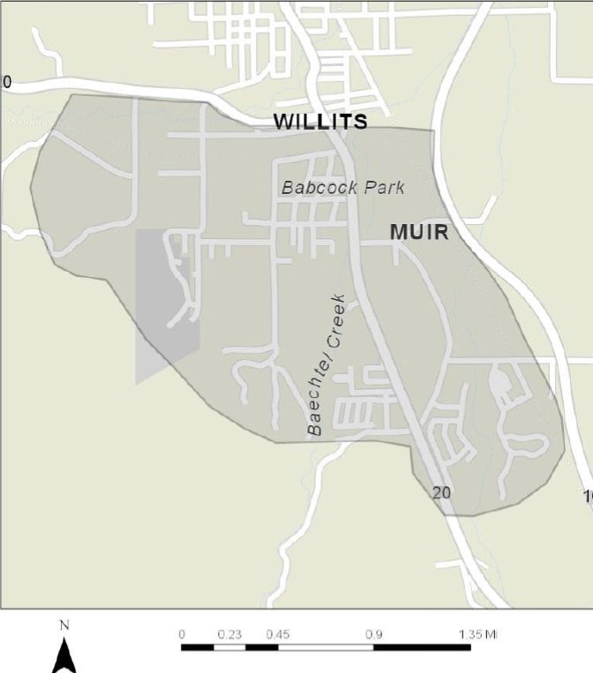
Example
[Repeat this section for each planning area with evacuation maps. Maps should show all relevant information, TCPs, Chokepoints, Access points, routes, refuges, AFN population, Critical infrastructure, etc.]
Traffic Control Points/Choke Points
Zone | Intersection | Restrict or Deny Entry | Choke Posfdsints | Reverse Lane Flows
[Zone Name] | [N Main @ Hwy 101] | X | X
[Zone Name] | [Hill Rd @ Idaho Ave] | X |  | X
[Zone Name] | [Amelia St. @ Sandy Dr.] | X | X | X
[Insert/add/takeaway your Jurisdictions TCPs and choke points]
Emergency Evacuation Shelters
Community / Area | Location | Coordinates
[A - Willis] | [American Legion Hall] | [39 47’39” N x 123 15’01” W]
[B- Truett] | [Fairgrounds – Livestock shelter] | [40 47’2” N x 130 18’01” W]
[Insert/add/takeaway your Jurisdictions Evacuation Shelters]
Transportation Facilities
Community / Area | Location | Coordinates
[Lakeview] | [AB Stadium] | [39 47’39” N x 123 15’01” W]
[Provide addresses, available resources (buses, ADA-compliant vehicles, fuel), and any Memorandums of Understanding (MOUs) with private or public transportation partners.]
Transportation Assets and Vehicles

Community / Area | Location | Number & Type
[Covelo] | [Round Valley High School  76280 High School Street] | 3- 40 Passenger Buses  6- 8 Passenger Vans
[Laytonville] | [Willits Harrah Senior Center  1501 Baechtel Road] | 1 - 8 Passenger Van WC-2

Vulnerable Population Locations

Community / Area | Location | Coordinates
[Northbrook Healthcare Center] | [64 Northbrook way, Wilits, ID, 12345] | [39 47’39” N x 123 15’01” W]

Special Hazard Areas
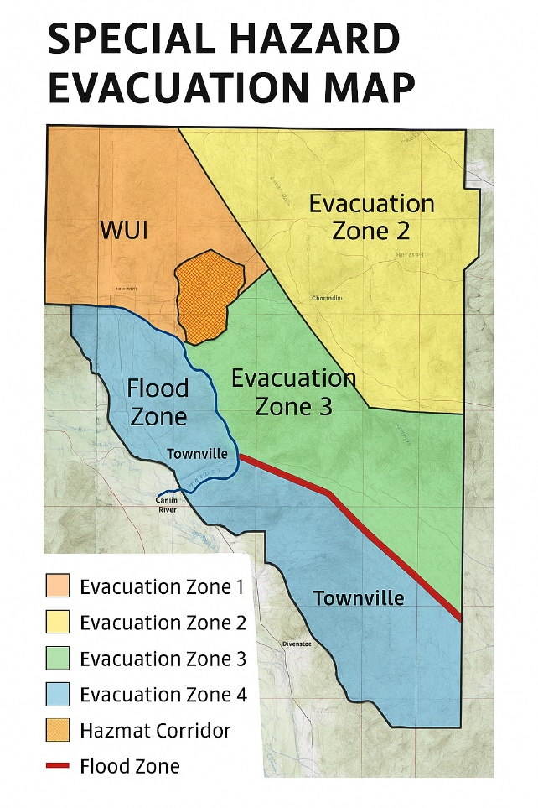
Example
[Include maps for floodplains, dam failure inundation areas, wildfire wildland urban interfaces (WUI), and HAZMAT corridors]
Post-Evacuation
Repopulation Plan:
As soon as possible after an evacuation, a Repopulation Plan should be developed. The pressure on local politicians and command staff to allow reentry will be significant. In most events, the Repopulation Plan will be developed at the EOC by the command staff. In most cases, the authorization for reentry will be made by the Sheriff in consultation with the EOC staff and subject matter experts. Considerations for allowing repopulation include:
- Damage assessment and utility restoration before public re-entry
- Hazardous material concerns mitigated
- Controlled access with law enforcement checkpoints
- Public info releases [2 hours] prior to re-entry

[Include the county’s phased re-entry checklist for residents, businesses, and contractors]

Recovery:
Recovery, different than repopulation, includes short-term and long-term efforts to rebuild and revitalize areas affected by disaster. For the purposes of this Plan, recovery will include the following tasks:
- Coordinate with FEMA, IOEM, and NGOs for shelter transition, debris removal, and financial assistance
- Support communication systems and processes that assist in the reunification of families
- Coordinate temporary housing for those who cannot return to their homes
- Coordinate assistance for those with access and functional needs in returning to a safe housing situation
- Initiate recovery activities for evacuees who have suffered loss of or damage to their homes or businesses as outlined in the County’s Recovery Plan

Plan Maintenance:
This Evacuation Plan will be maintained by [insert responsible party]. As changes are needed to Plan Appendices, [responsible party] will facilitate these changes, coordinating and communicating this work with applicable stakeholders.
- Reviewed [annually] by the County Emergency Manager
- Updated after major incidents or exercises

After-Action Review:
The After-Action Review (AAR) process is an evaluation of the County’s evacuation efforts to a major emergency/disaster. It should occur after every full EOC activation. The output of the review is a report of findings detailing how the incident could have been handled better. Specific to this Plan, the following evaluations should include:
- Conduct within [30] days of incident
- The use and effectiveness of transportation and route selection between the evacuation zone and shelter(s)
- The coordination between transportation resources and the EOC to safely evacuate residents
- The effectiveness of collaborating with neighboring jurisdictions, schools, and businesses
- The ability to ensure that the County’s access and functional needs populations were effectively handled
- Any additional lessons learned

Roles and Responsibilities
All County Departments
[Insert/add/takeaway your organizations specific roles and responsibilities]
- Information Sharing: Provide timely and accurate updates to the Incident Command Post (ICP) or Emergency Operations Center (EOC)
- Resource Coordination: Identify available resources and request support through proper channels (EOC or EMAC)
- Public Communication: Support consistent messaging for evacuation orders, routes, shelters, and re-entry procedures
- NIMS/ICS Compliance: Operate within the Incident Command System and follow established communication protocols
- Documentation: Maintain records of decisions, actions, and resources for expenditure reimbursement and after-action review
- Support for Access and Functional Needs (AFN): Ensure planning and operations include provisions for individuals with disabilities, language barriers, or transportation limitations
- Support evacuation operations by providing personnel and/or resources as requested by the County EOC/ICP

Incident Command
[Insert/add/takeaway your organizations specific roles and responsibilities]
- Establish and lead the Incident Command Post (ICP)
- Provide recommendations to the Sheriff regarding the need for evacuation
- Coordinate with EOC for resource requests, public information, and sheltering operations
- Assign operational sections (Operations, Planning, Logistics, Finance/Admin) as needed
- Identify any recommended transportation routes/corridors for evacuees and emergency response personnel
- Determine mass transit resources or other modes of transportation (air, rail, water/boat) as appropriate to the incident
- Initiate field warning operations (door-to-door, public address systems, etc.)
- Identify staging areas for evacuation related resources
- Track assigned and unassigned resources supporting evacuation operations
- Initiate Access and Functional Need (AFN) population specific needs and special considerations
- Ensure responder safety during evacuation operations

Sheriff’s Office and Local Law Enforcement
[Insert/add/takeaway your organizations specific roles and responsibilities]
- Implement evacuation orders and enforce restricted-area access
- Conduct door-to-door notifications, traffic control, and perimeter security
- Assist with re-entry operations and maintain law and order during evacuation and repopulation
- Coordinate with neighboring jurisdictions and Idaho State Police for mutual aid support
- Document refusal cases and communicate them to the ICP/EOC
Fire Chief/Fire Operational Area Coordinator
[Insert/add/takeaway your organizations specific roles and responsibilities]
- Assess fire-related threats (wildfire spread, smoke impacts, structure vulnerability)
- Provide technical evacuation recommendations based on fire behavior modeling and predicted spread
- Coordinate structure defense and suppression activities with evacuation timing to minimize conflicts
- Serve as a liaison to IC or Unified Command when wildfire is the primary hazard
County Emergency Manager
[Insert/add/takeaway your organizations specific roles and responsibilities]
- Activate and manage the Emergency Operations Center (EOC).
- Coordinate multi-agency response and resource requests (IMAC/EMAC).
- Ensure public information is coordinated through the Joint Information System (JIS).
- Track evacuation status, resource deployment, and unmet needs.
- Facilitate after-action review and update the evacuation plan based on lessons learned.
Transportation Department
[Insert/add/takeaway your organizations specific roles and responsibilities]
- Identify and maintain primary and alternate evacuation routes. Monitor route conditions and provide updates to ICP/EOC
- Deploy traffic control devices, barricades, and signage as requested by the IC
- Clear debris and remove obstructions to maintain route access
- Conduct roadway assessments for structural integrity (bridges, overpasses, tunnels) during evacuations
- Provide transportation resources (buses, vans, fuel) for evacuation of AFN or carless populations

Health and Human Services
[Insert/add/takeaway your organizations specific roles and responsibilities]
- Coordinate evacuation and sheltering of medical facilities, assisted living centers, and vulnerable populations
- Provide mental health and crisis counseling support to evacuees
- Assist with family reunification and support services in shelters
- Deploy public health staff to monitor sanitation, disease control, and special medical needs in evacuation centers
Board of County Commissioners
[Insert/add/takeaway your organizations specific roles and responsibilities]
- Issue or ratify local disaster/emergency declarations when required
- Provide policy-level support and resource authorization to the IC/EOC
- Act as public-facing representatives during press conferences and community briefings
- Approve emergency contracts or mutual aid agreements as needed
Department of Building and Planning
[Insert/add/takeaway your organizations specific roles and responsibilities]
- Identify critical infrastructure and high-risk developments within evacuation zones
- Provide maps, GIS data, and building code compliance information to assist in evacuation decision-making
- Assist in damage assessment and post-event inspections before re-entry
- Recommend building or zoning changes after events to reduce future evacuation needs
[Add additional organizations roles and responsibilities]

